From Field to Data
Using UMEA Scores to Identify Performance Trends and Competitive Gaps in Marching Band Competitions
By: Craig Case
December 11, 2025

For the past four years my daughter has participated in high school marching band. This has been a great experience for my wife and me. After each competition for the past two years my wife has reached out to the UMEA (Utah Music Educators Association) and we have reviewed the scores for each caption (category) and division. This past year I started looking at the score myself. I realized there was a treasure trove of data. Score that went as far back as 2014. I concluded that I could organize this data into a tool band instructors and staff could use to improve their programs.

The goal for this project would be to enable band directors and staff to identify competitive gaps for improvement, target specific captions, and track each season’s progress using the objective data on the UMEA marching band site at: https://umea.us/divisions/marching-band/.

Data Extraction:
I concluded that collecting the data was going to be the most exciting and challenging part of this project. You see, the UMEA marching band site is multi-layered. It starts with a list of competition seasons, within each season are multiple competitions or shows. Within each competition are multiple division competitions, and within each division competition are multiple performances. To top this off, each performance is scored in multiple categories, called “captions.” Each division competition within a show is summarized in a table. Like this one:
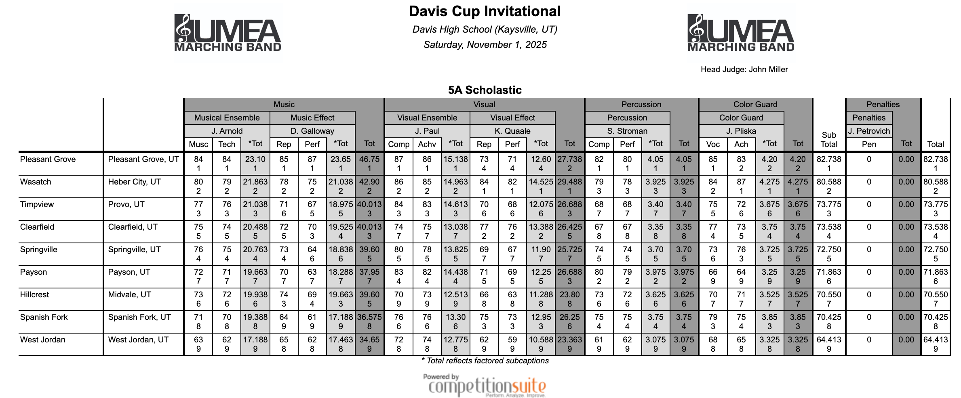
This complicated hierarchy should have been a red flag for me.
The first step was to gather a list of all the show GUIDs Globally Unique Identifier). This would give me a access to the tables, as seen above. These tables contain all the scores for each performance. I initially tried to parse the list of competitions using the Python Library, ‘beutifulsoup’. However the UMEA servers recognized I was accessing the site with a bot, and blocked my access. It took a while, but I was able to find an API end point I could call to get the data. From this API I was able to generate a list of GUIDs as well as a CSV file containing high level information of each competition and performance.
First, I built a dictionary of GUIDs for each season. Here is the dictionary:
SEASON_GUID_DICT = {'UMEA 2025': 'ff7a5f4b-b7dc-4cbc-ad0b-1295fdd971a8', 'UMEA 2024': '9cd94b0d-a521-4280-98e3-b42b4c4441c5', 'UMEA 2023': 'baa6c584-4547-4370-b8ca-2d05018876d7', 'UMEA 2022': '6d7e8a01-34fb-49c0-bfab-8b62c8f19930'}#, 'UMEA 2021': '871de29c-53ea-4b45-b69a-cbb245861811', 'UMEA 2020': '9e9a151d-762c-4024-aa5a-aa45930939e1', 'UMEA 2019': 'a6bbdab4-a781-4a21-850a-53d42faebe2b', 'UMEA 2018': 'ad102698-0fc8-451a-a5fd-634da78d103d', 'UMEA 2017': 'ea245774-1ae0-464d-92a9-1ddf44600c51', 'UMEA 2016': '334709e3-d486-4cda-b0fb-fbbf0d64966d', 'UMEA 2015': '26b74c10-b696-428f-8463-874b147c606d', 'UMEA 2014': '6cfb281c-6122-4115-8c3b-f0a2097aa48d'}

Second, I wrote code to access the API and retrieve a JASONP dictionary. This is the code I used to access the API:
import requests

url = "https://bridge.competitionsuite.com/api/orgscores/GetCompetitionsBySeason/jsonp"
params = {
"season": season_id, #from SEASON_GUID_DICT above
"showTrainingEvents": "false",
“version” = "1.1.5”
“callback” = "jQuery110209904385531594735_1763353270252?_= 1763353270271"
#Here we are being nice to the API and sending requests a random time intervals.
random_float = random.uniform(0, 3)
time.sleep(random_float)

resp = requests.get(url, params=params, timeout=timeout) # this line makes the request to the API.

I wrote two functions that took the returned and transformed dictionary and wrote out two files. One big list of GUIDs for each division competition, and one csv file that contained all the high level show data.

